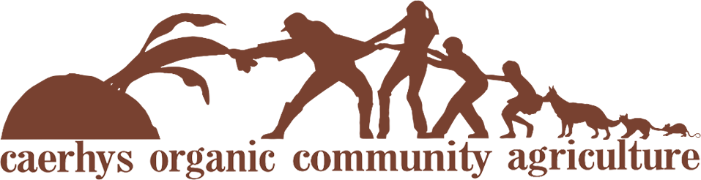
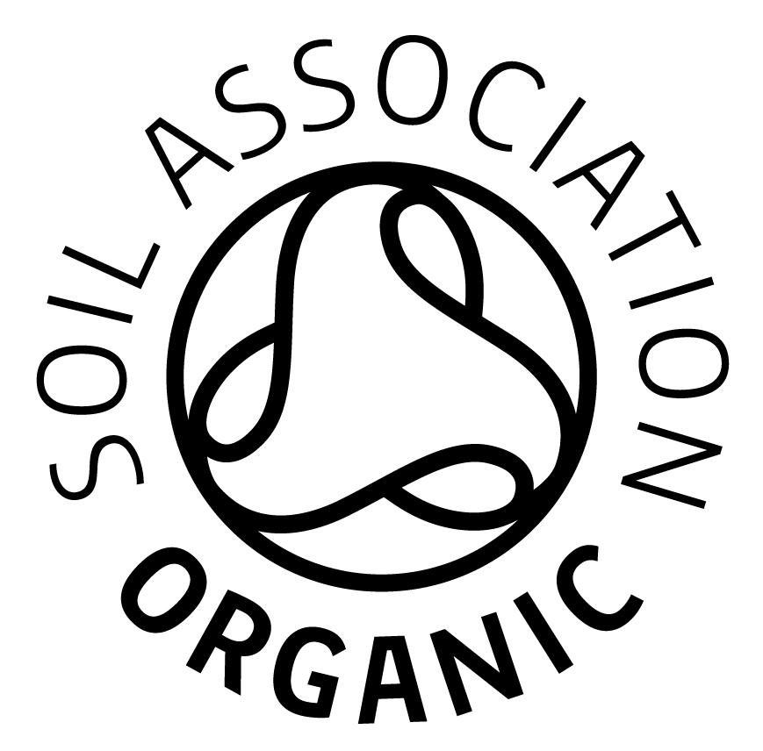

Membership Application

By becoming a member of Caerhys Organic Community Agriculture (COCA) I confirm that
- I support the vision, aims and principles of COCA (see COCA website: www.coca-csa.org)
- I will pay my subscription by standing order at the beginning of each calendar month.
- I will give 1 months’ notice of ceasing membership.
- I will support the project through good times and poor recognising that there will be a time of year when little fresh produce will be available – the “hungry gap”.
- I will aim to help with one of COCA’s workgroups.
- I accept liability of £1 of COCA debts upon dissolution (COCA is a company limited by guarantee)

Monthly subscription
      - A SMALL veg share is £28 per month (minimum) if picked up from Caerhys Organic Farm or £33 from a remote pick-up point and is typically suitable for one to two people.
- A LARGE veg share is £50 per month (minimum) if picked up from Caerhys Organic Farm or £55 from a remote pick-up point and is typically suitable for two people or a small family.

- Please set up a standing order with your name as a reference. COCA’s bank account is at the Co-operative Bank with the following details.
Account name: Caerhys Organic Community Agriculture
Account number: 65403024 Sort code: 08-92-99

- Please tick one of the following boxes:
A trial share for a month: Small Large
I wish to become a veg-sharing member: Small Large
I wish to support COCA by becoming a member, but do not want to take a veg share.

- Please also tick one of these boxes:
I want to pick up my veg share from: Caerhys Farm Haverfordwest Fishguard

- I will set up my standing order of £ ............... to begin on ...…………………………....(1st of a month please)

Name: ………………………………………………………………… Email address: ….…….....…………………………………
Address: ………………………………………………………………………………………………………………………………….....
Postcode: ………………… Telephone: ………………………………............... Mobile: ……………………………………...
Date: ……………………………… Signature: …………………………………………………………………………………………

What to do next
Either:
- Email this form to Secretary@coca-csa.org and copy Treasurer@coca-csa.org (preferred option)
- Or post the form to COCA Membership, The Gables, Puncheston, Haverfordwest, SA62 5RJ
- Or leave the form in the COCA communication box, which is in the share shed at the farm

If you have chosen a veg-share subscription, then begin collecting your vegetables as soon as your first standing order payment has been made. If have any questions or need any more information, please contact Caerhys Organic Farm on 01348 831244 or email Secretary@coca-csa.org.
- Please tick this box if you would prefer not to receive email correspondence from COCA.

