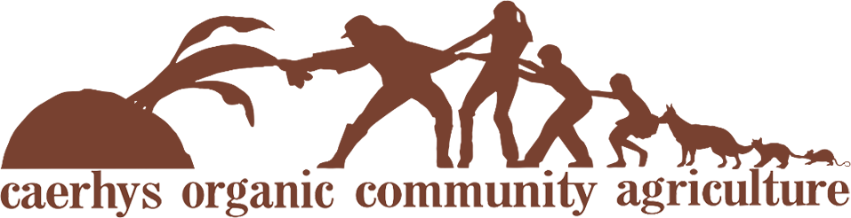

COCA Membership Application

- I would like to become a member of Caerhys Organic Community Agriculture (COCA) and confirm that:
- I have read and support the vision, aims and principles of COCA (published on the COCA website at www.coca-csa.org) and will comply with the rules of the association.
- I will pay my subscription by standing order at the beginning of each calendar month.
- I will give 3 months’ notice of ceasing membership.
- I will support the project through good times and poor recognising that there will be a time of year when little fresh produce will be available – the “hungry gap”.
- I will attend the Annual General Meeting each year.
- I may decide to help with one of COCA’s workgroups, but know that there is no obligation to do so.
- I accept the risk that there may be no return or profit on any payments I make to COCA.
- I accept liability of £1 of COCA debts upon dissolution (COCA is a company limited by guarantee)
Monthly subscription
COCA membership is included in whichever veg-share subscription you choose. Veg shares have a minimum price, but please pay as much as you can afford.
- A small veg share is £25 per month (minimum) if picked up from Caerhys Organic Farm or £29 from a remote pick-up point and is typically suitable for one to two people.
- A large veg share is £47 per month (minimum) if picked up from Caerhys Organic Farm or £51 from a remote pick-up point and is typically suitable for two people up to a small family.
- Please set up a standing order with your name as a reference. COCA’s bank account is at the Co-operative Bank with the following details.
Account name: Caerhys Organic Community Agriculture
Account number: 65403024
Sort code: 08-92-99
- Please tick one of the following boxes:
I want to pay cash for a one month trial : Small Large for the month of...……………….only
I wish to become a veg-sharing member: Small Large
I wish to support COCA by becoming a member, but do not want to take a veg share.

- Please also tick one of these boxes:
I want to pick up my veg share from: Caerhys Farm Haverfordwest Fishguard
- I will set up my standing order of £ ............... to begin on ...………………………………….... (1st of a month please)
Name: ………………………………………………………………… Email address: ………………………………………………………
Address: ……………………………………………………………………………………………………………………………………………..
Postcode: ………………………. Telephone: ………………………………............... Mobile: …………………………………………
Date: ……………………………… Signature: ………………………………………………………………………………………………….
- What to do next
Either:
- Email this form to Secretary@coca-csa.org and copy Treasurer@coca-csa.org (preferred option)
- Or post the form to COCA Membership, The Gables, Puncheston, Haverfordwest, SA62 5RJ
- Or leave the form in the COCA communication box, which is in the share shed at the farm
If you have chosen a veg-share subscription, then begin collecting your vegetables as soon as your first standing order payment has been made.
If have any questions or need any more information, please contact Nathan on 07971114301 or email him at Secretary@coca-csa.org.

